Swim Schools - New Feature - Assign whole Organisation

The Swim School Hub has added a new feature this month. The system now has a group called “Whole Organisation”. This group is automatically updated when new users are added to your swim school or a user is removed when you disable them.
Example:
Assign a training module (or a competency or resource) to the whole organisation.
Step 1 – Click on the “Modules” tab
Step 2 – Click on “Action” next to module you wish to assign to the whole organisation
Step 3 – Click on “Assign Groups”
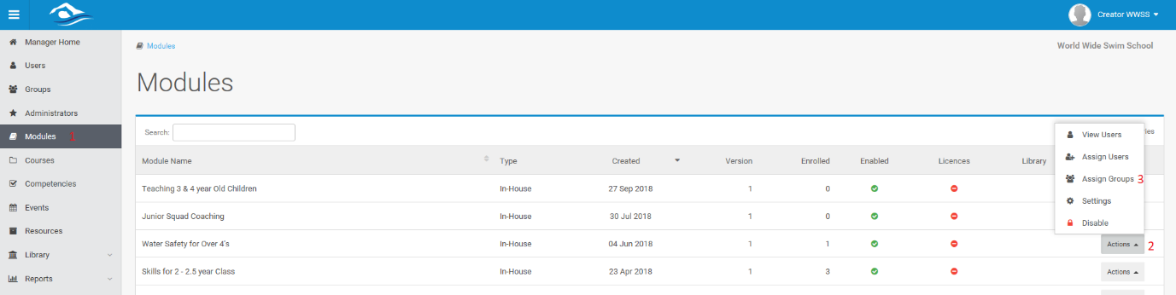
Step 4 – Check the Add box for “Whole organisation”
Step 5 – Select licence (this will only add licence to any user not already assigned on)
Step 6 – Choose a “Complete by Date” (this will give the users a due date & automate follow up emails)
Step 7 – Leave “Notify by Email” checked (so all users receive an email letting them know they have been assigned the module and when it is due, including their login details)
Step 8 – Click “Save Changes”
